
LUTHERAN WOMEN IN MISSION
President’s Report
Fall, 2026
“Serve the LORD with gladness!” Psalm 100:2 Elaine Engelman
president@kansaslwml.org
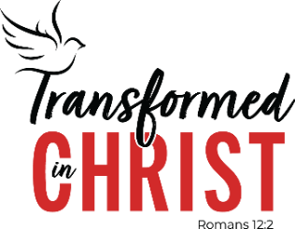
We are less than a year away from the 2027 National Convention in
Oklahoma City!! The convention will be held in the Oklahoma City Convention Center, 100 Mick Cornett Drive, Oklahoma City, Oklahoma 73109. Volunteers who work two (2) four-hour shifts are eligible for a reduced registration fee and the earlier you register the bigger the discount. There are several areas of service outlined in The OKC Sign Post and they have noted a few that can be done from home before the convention.

If you have not sent in your volunteer form yet, please prayerfully consider doing so. I have a few copies of the form with me; you will also find a copy in the fall issue of the Kansas Sonshine and in The OKC Sign Post.

The Kansas District will not be able to furnish a bus to the OKC national convention in 2027. Please check with members of your group that may be interested in attending, but are not inclined to drive in Oklahoma City, and offer to let them travel with you if you are able.

Your zone presidents have received a copy of the application for national Young Woman Representatives (YWRs). Any young woman between the ages of 20-35 who would like the opportunity to represent the Kansas District at the 2027 national convention in Oklahoma City should apply. Ordinarily each District is allowed to send two YWRs to the convention. The deadline to send in completed applications to Vice President of Special Focus Ministries Tiffany Harkins is December 19. Applications can be emailed to Tiffany at specialfocus@kansaslwml.org.

Your zones also need to select their delegate and alternate for the 2027 convention soon. It is very important to have both positions selected! I send information regarding the national convention to both women selected and it is much easier to remember what has been reported to whom if it is all done at the same time. By having all the information as it comes out, whoever is able to attend will be prepared to vote on important issues for you, the women they represent.

Whatever your zone’s process is for that selection, please have complete contact information for those two women to me by December 1, 2026. The information includes: name, mailing address, email address, and telephone number (home and cell if they have them). The sooner that information is available, the sooner it can be transferred into our national delegation form. It has been tradition in the past that the sooner Districts get their information in, the closer they are seated to the stage in the delegation section.


LWML Sunday is traditionally observed the first Sunday of October, but it can be celebrated at any time. This year’s theme continues a four-year cycle focusing on the LWML Mission Statement — As Lutheran Women in Mission, we joyfully proclaim Christ, support missions, and equip women to honor God by serving others. For Lutheran Women in Mission Sunday 2026, we focus on Supporting Missions. This theme is based on the texts: Ecclesiastes 3:9–15, Galatians 2:1–10, and Mark 10:35–45.
2026 Lutheran Women in Mission Sunday downloadable materials, authored by Rev. Mark Maas, are available at lwml.org/lwmlSunday.

The Executive Committee (EC) voted to pay the first mission grant during our meeting on July 10, 2026. However, that mission grant was not ready to receive the funds when contacted. According to the District Leadership Guidelines, the next mission grant is asked if they are ready and Mission Grant (MG) #2 Orphan Grain Train in Phillipsburg, Kansas for $5,000.00 was paid. When it was time to pay the next mission grant, ICOA was contacted and they are still not ready, so we paid Mission Grant #3—Fairmount Ministries and Coffee Company for $8,000.00. Praise God we have been able to pay both Mission Grant #2 and #3 at this time! We continue to pray for Mission Grant #1, that they will be able to get their project plans back on track.

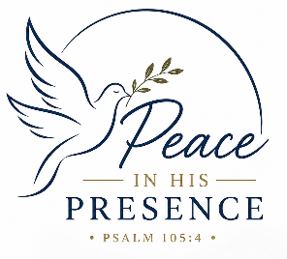
During the last Board of Directors (BOD) meeting in Salina July 10, The logo to the right was chosen for the 2028 Convention logo and Psalm 105:4 was chosen as the 2028 Convention theme verse. Seek the LORD and his strength; seek his presence continually!

The following Convention Goal statement was also adopted -
Remembering the wondrous work He has done, we will seek peace in his presence by:
- Abiding in the Lord’s strenght through Word and Sacrament;
- Singing praises and giving thanks through hymns and prayer; and
- Telling the Good News to all peoples continually.

If you know of someone who has served as a missionary overseas recently that might be interested in speaking to our 2028 convention body as the Bible Study leader, main speaker and/or interest session and leadership session presenters, please give me their contact information or send it to president@kansaslwml.org. We will begin contacting speakers and presenters soon after the first of the year (2027), so the sooner we get names, the better.

The Kansas District Nominating Committee for the 2028 District Convention will come from the following zones: Hutchinson, Northeast, Northwest, Southeast, and Southwest. Each zone should have one woman to serve on this committee; her name should be sent to President Elaine no later than February 1, 2027. If that position could be filled here at the fall 2026 zone events that would be really great! The District positions to be elected for 2028-2032 are District President, VP of Caring Service, VP of Communication, Financial Secretary, and Recording Secretary. As the nominating committee begins its work in 2027, please pray that all positions in our LWML district will be filled with women willing to serve with gladness as officers of our LMWL district.
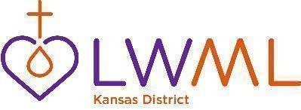
Dates to remember - 2026
Sept 26 – Oct 24 zone events
Nov. 6/7—86th annual KS District LLL Convention in Hutchinson (President Elaine bringing greetings)
Nov. 13/14—Exec Committee mtg in Emporia; location TBD
Dec. 1—deadline for convention delegate and alternate information to President Elaine
Dec. 5—deadline for winter Kansas Sonshine articles
Dec. 4-14—President Elaine out of the office, but available by email or text
Dec. 19—deadline to submit national YWR applications to District VP of Special Focus Ministries, Tiffany Harkins

Dates to remember – 2027
January 18-20 President Elaine attends LWML Presidents’ Assembly
February 1 deadline for names of District nominating committee members
February 13/14 EC meeting #1, location TBD
April 2028 convention planning meeting #2, location TBD
May 1/2 EC meeting #2, location TBD

LWML KANSAS DISTRICT PRIMARY FOCUS AREAS -- 2026-2028 Biennium
Proclaiming Christ
Declare his glory among the nations, his marvelous works among all peoples! (Psalm 96:3).
Supporting Missions
And he said to them, “Go into all the world and proclaim the gospel to the whole creation
(Mark 16:15).
Equipping Women
Now may the God of peace … equip you with everything good that you may do his will
(Hebrews 13:20-21).
Serving Others
As each has received a gift, use it to serve one another (1 Peter 4:10a).

LWML KANSAS DISTRICT MISSION STATEMENT
Led by the Holy Spirit, the LWML Kansas District will equip women to proclaim Christ,
support missions, and serve the Lord with gladness.
LWML MISSION STATEMENT
As Lutheran Women in Mission, we joyfully proclaim Christ, support missions,
and equip women to honor God by serving others.

