To: LWML Zone Presidents
LWML Zone Special Focus Ministries Chairmen
Attention all Zone Presidents and Zone SFM Chairmen: Please see that each groups counterpart listed below gets a copy of the enclosed pages.
* * * * * * * * * * * * *

To: LWML Group Presidents
LWML Group Special Focus Ministries Chairmen LWML Members
Greetings from the Kansas District Special Focus Ministries Committee!

The Kansas District LWML Special Focus Ministries Committee will be hosting a special program for Young Women Representatives at the Kansas District LWML Convention April 17-19, 2026, in Manhattan, Kansas.

Each Zone in the Kansas District will be able to sponsor two Young Women Representatives (YWR’s). The suggested age is 20 through 35 (as of March 28, 2026). Other information about the application process is listed in the attached guidelines.

Please encourage any young woman fitting the guidelines to apply. The application does not have to be given out only by the Presidents or Special Focus Ministries Chairmen; any LWML member may, and should, encourage a young woman to apply!

The completed application forms need to be postmarked no later than January 15, 2026, and should be returned to the Zone President. Each Zone will be responsible for selecting two Young Women Representatives and submitting the two chosen YWR applications to the SFM Committee, along with the convention registration forms and a check to cover the registration fees. Hotel Reservations will be made by the Kansas District LWML Special Focus Ministries Committee. Each Zone will be responsible for paying the hotel expenses for their YWR upon checkout.

All forms and fees are to be submitted to the KS District Special Focus Ministries Committee by
February 1, 2026. Please direct any questions and the registration forms to:

Sarah Kleopfer
2526 Coyote Rd
Morrill, KS 66515
sarahkleopfer@gmail.com

In His Name,
Sarah Kleopfer
KS District VP Special Focus Ministries

GUIDELINES FOR APPLICATION FOR KANSAS DISTRICT YOUNG WOMAN REPRESENTATIVE

What is a Young Woman Representative? The YWR (acronym) is a young woman who represents her church, group, zone and district for the Lutheran Women’s Missionary League (LWML); she does not have to be a member of LWML! She will attend the District convention as a special guest and have the opportunity to see how the LWML operates in its missionary service. More importantly, she is mentored on how to develop a strong relationship with God and others through her work in LWML.

Who may apply?
- She must be a mature young woman between the ages of 20-35 (as of March 28, 2024) who is a member of the Kansas District Lutheran Church-Missouri Synod.
- She shall have a deep love and devotion to her Lord Jesus Christ and be willing to participate in all aspects of the YWR program of the LWML.
- She must be able and willing to attend all sessions and YWR activities of the convention. YWR’s will be seated together but will not vote.
- She must be able to be away from home and/or work for the convention.

What can the YWR expect from the experience?
- She will be given a “mountain-top” experience that will be spiritually uplifting, inspiring, fun-filled, entertaining and interesting.
- She will be a special guest at the convention, and the Zone LWML will cover registration, travel, housing and meal package costs.

What can the District expect of the YWR?
- The YWR will become an active participant in her group, zone and the district.
- The YWR will encourage other young women to become part of the excitement.
- The YWR will complete a Personnel Resource Profile after the convention.

How to apply:
- Complete the attached forms (4 pages) and return it to your Zone President -
Zone President Name
Address
Telephone E-mail
- The application must be returned and/or postmarked no later than January 15, 2026.
- Each Zone Committee will select two YWR’s to the Kansas District LWML Convention, and send their selections to the Special Focus Ministries Committee by February 1, 2026.
- All applicants will be notified by their Zone President also by February 1, 2026, with the selection of the applicants chosen to represent their zone as a YWR at the Kansas District LWML Convention.

Questions? Contact: Sarah Kleopfer 785-741-1832 or @gmail.com

YOUNG WOMAN REPRESENTATIVE APPLICATION

Manhattan, Kansas - April 17-19. 2026

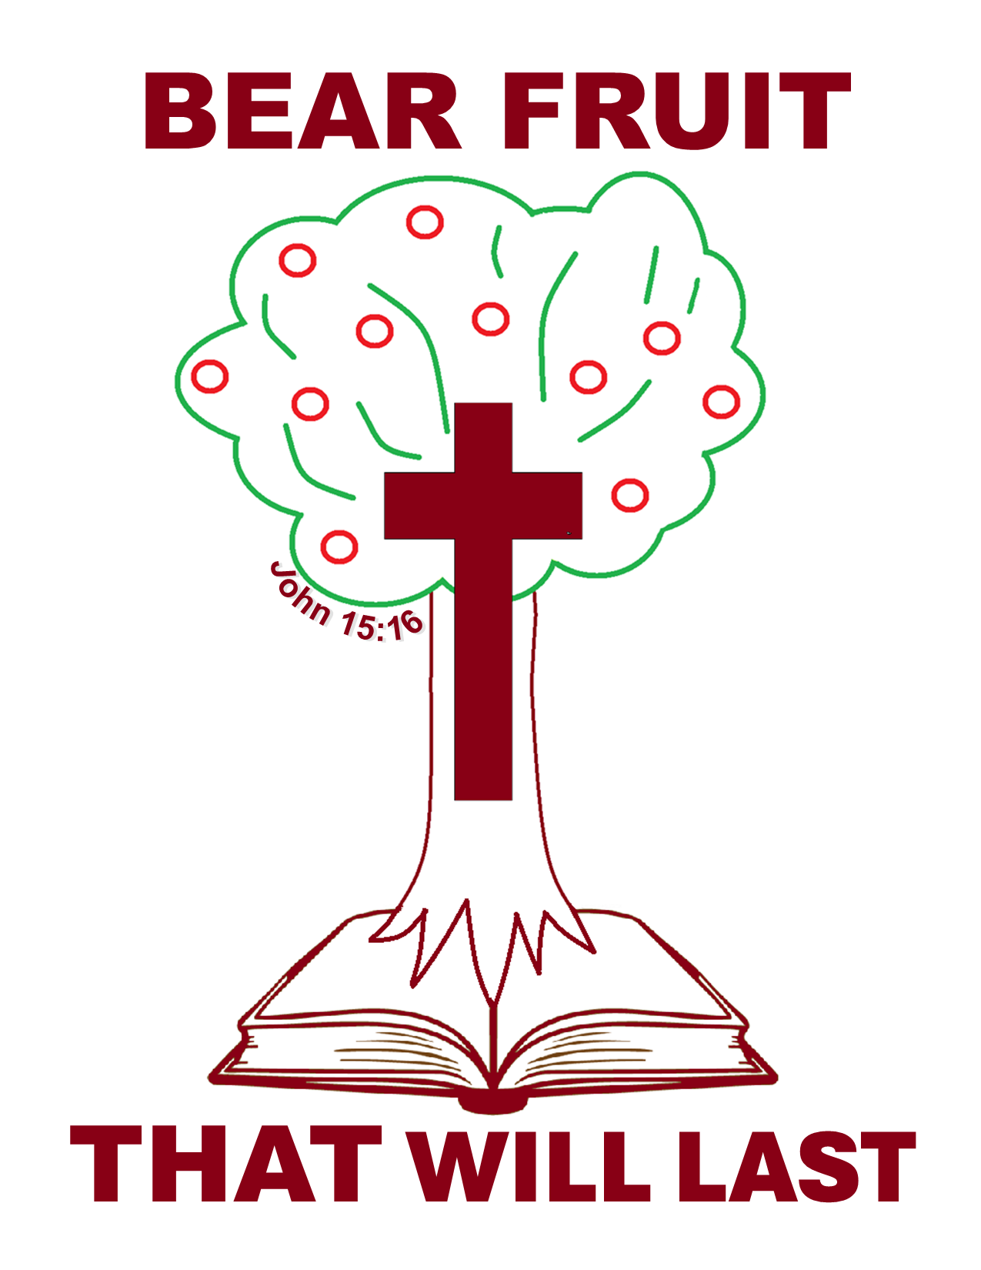

Name Age

Address

City , Kansas Zip Code

Telephone E-mail

Occupation

Home Congregation

Church City

LWML Zone

Page 1

Please answer the following questions. You may use the back or another sheet if needed.

- The LWML motto is “Serve the Lord with Gladness” (Psalm 100:2). How do you do this in your life?

- What is your knowledge of and level of participation in LWML, if any?

- Why do you desire to be a Young Woman Representative for this Zone at the Kansas District LWML Convention?

Page 2

- What groups/activities have you been active in at church?

- What do you feel are your gifts and talents?

- Complete the 3 page YWR application form and return it to your Zone President by January 15, 2026. (Be sure to enclose the “Letter of Reference” also.)

- Ask someone who knows you well (perhaps the person who encouraged you to apply) to complete the “Letter of Reference” form, and return it to your Zone President, along with the YWR application forms.

Questions? Sarah Kleopfer 785-741-2832– or – sarahkleopfer@gmail.com
- This complete application (4 pages) must be mailed to your Zone President and postmarked no later than January 15, 2026.

Page 3

YOUNG WOMAN REPRESENTATIVE APPLICATION
Letter of Reference

Applicant’s Name

“Why do you feel that this individual would be a good Young Woman Representative (YWR) to the Kansas District LWML Convention?

Reference written by:

Name Phone

Relationship to Applicant E-mail

Local LWML Society President Signature

Return this letter of reference to the YWR applicant, so she may return it to her Zone President with the YWR application forms.

Questions? Contact Sarah Kleopfer: 785-741-1832 or sarahkleopfer@gmail.com The application must be postmarked no later than January 15, 2026

