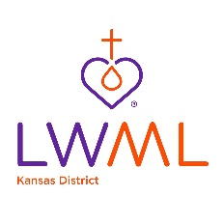
Memorials/Honorariums may be given to any of these designated funds of the LWML KS District:

- God’s Gracious Gift Fund (GGGF) - Funds are disbursed to mission organizations, schools or other special grants based on the vote of the delegates at each convention.
- District Mission Grants - Funds are disbursed to mission organizations, schools or other special grants based on the vote of the delegates at each convention. These funds are paid as mite offerings and mission grant donations are received.
- Student Financial Aid (SFA) - Funds are awarded to qualified applicants who attend the Concordia Universities or seminaries and enroll in church work program studies.
- Leader Development - Funds are used to develop LWML women as leaders in the Kansas District.

Fill out the form below and mail to the Financial Secretary of the LWML Kansas District. Make check payable to the LWML Kansas District. Your canceled check is your receipt.
LWML Kansas District Financial Secretary
PO Box 314
Arma, KS 66712
OR
Make your donation online and indicate the fund you desire to designate for your donation.
THANK YOU FOR YOUR GIFT!
___________________________________________________________________
To God’s Glory
A gift of $Amount to the LWML Kansas District ☐ is enclosed.
☐ In loving memory of -OR- ☐ In honor of
Name
This contribution is to be used for the LWML Kansas District (please mark one)
☐ God’s Gracious Gift Fund
☐ District Mission Grants
☐ Student Financial Aid
☐ Leader Development

Given by: YOUR Name
Address: YOUR Address

For memorials or honorariums, the card on the next page may be given to the family or individual.
4/1/2023 kso

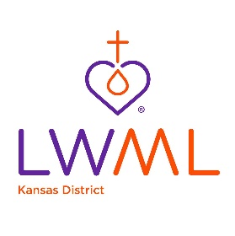
To God’s Glory
☐ A gift in loving memory of -OR- ☐ A gift in honor of

Name

has been made to the
Lutheran Women’s Missionary League Kansas District
☐ God’s Gracious Gift Fund
☐ District Mission Grants
☐ Student Financial Aid
☐ Leader Development

By YOUR Name
Address YOUR Address

